Exercise 1: Create a Stored Procedure
--Step 1: Create Database
CREATE DATABASE CollegeDB;
GO
USE CollegeDB;

CREATE TABLE Student(
StudentID INT PRIMARY KEY,
StudentName VARCHAR(50),
Department VARCHAR(30),
Marks INT
);

INSERT INTO Student VALUES
(101,'Aarav','CSE',85),
(102,'Bhavya','ECE',90),
(103,'Charan','CSE',78),
(104,'Divya','EEE',88),
(105,'Esha','CSE',92);

--Display Table
SELECT * FROM Student;
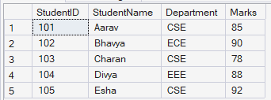
--Create Stored Procedure
CREATE PROCEDURE GetStudentsByDepartment
@Department VARCHAR(30)
AS
BEGIN
SELECT *
FROM Student
WHERE Department = @Department;
END;
GO

--Execute Stored Procedure
EXEC GetStudentsByDepartment 'CSE';
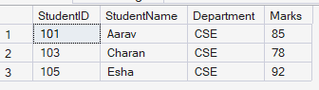

--Execute for Another Department
EXEC GetStudentsByDepartment 'ECE';
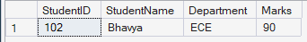

--View the Stored Procedure
sp_helptext GetStudentsByDepartment;
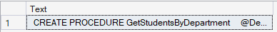

Exercise 5: Return Data from a Stored Procedure
CREATE DATABASE HospitalDB;
GO

USE HospitalDB;

CREATE TABLE Patients
(
PatientID INT PRIMARY KEY,
PatientName VARCHAR(50),
Disease VARCHAR(50),
Age INT,
BillAmount DECIMAL(10,2)
);

INSERT INTO Patients VALUES
(101,'Rahul','Fever',25,2500.00),
(102,'Sneha','Diabetes',45,12000.00),
(103,'Arjun','Asthma',30,8000.00),
(104,'Priya','Fever',22,3000.00),
(105,'Kiran','Cancer',55,50000.00);

SELECT * FROM Patients;
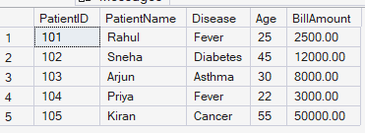
--Create Stored Procedure (Return Data)
CREATE PROCEDURE GetPatientDetails
@PatientID INT
AS
BEGIN
SELECT
PatientID,
PatientName,
Disease,
Age,
BillAmount
FROM Patients
WHERE PatientID = @PatientID;
END;
GO

--Execute Stored Procedure
EXEC GetPatientDetails 103;
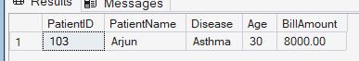

--Execute for Another Patient
EXEC GetPatientDetails 105;
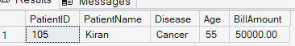

--View Stored Procedure
sp_helptext GetPatientDetails;
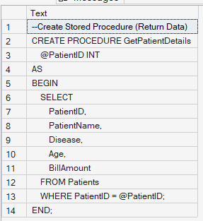

Exercise 4: Execute a Stored Procedure
USE BankDB;
GO
IF OBJECT_ID('Accounts', 'U') IS NOT NULL
DROP TABLE Accounts;
GO
CREATE TABLE Accounts(
AccountID INT PRIMARY KEY,
CustomerName VARCHAR(50),
AccountType VARCHAR(20),
Balance DECIMAL(10,2)
);
INSERT INTO Accounts VALUES
(101,'Rahul','Savings',25000.00),
(102,'Sneha','Current',45000.00),
(103,'Arjun','Savings',32000.00),
(104,'Priya','Current',50000.00),
(105,'Kiran','Savings',60000.00);

DROP PROCEDURE IF EXISTS DisplayAccounts;
GO

CREATE PROCEDURE DisplayAccounts
AS
BEGIN
SELECT *
FROM Accounts;
END;
GO

EXEC DisplayAccounts;
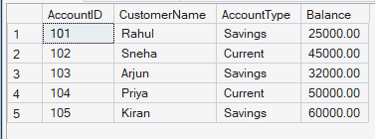

sp_helptext DisplayAccounts;
